31. Morphological operations based on OpenCV using Opening technique.

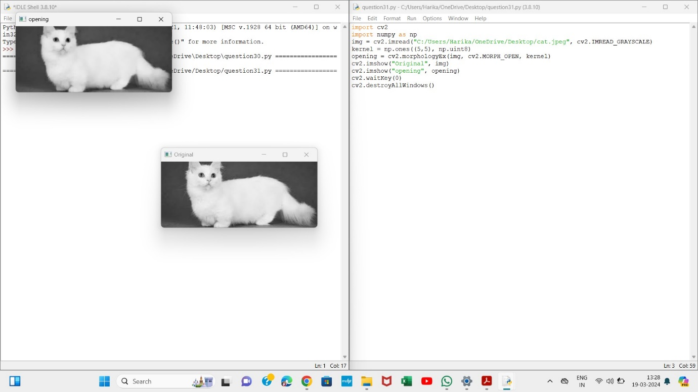

32. Morphological operations based on OpenCV using Closing technique.

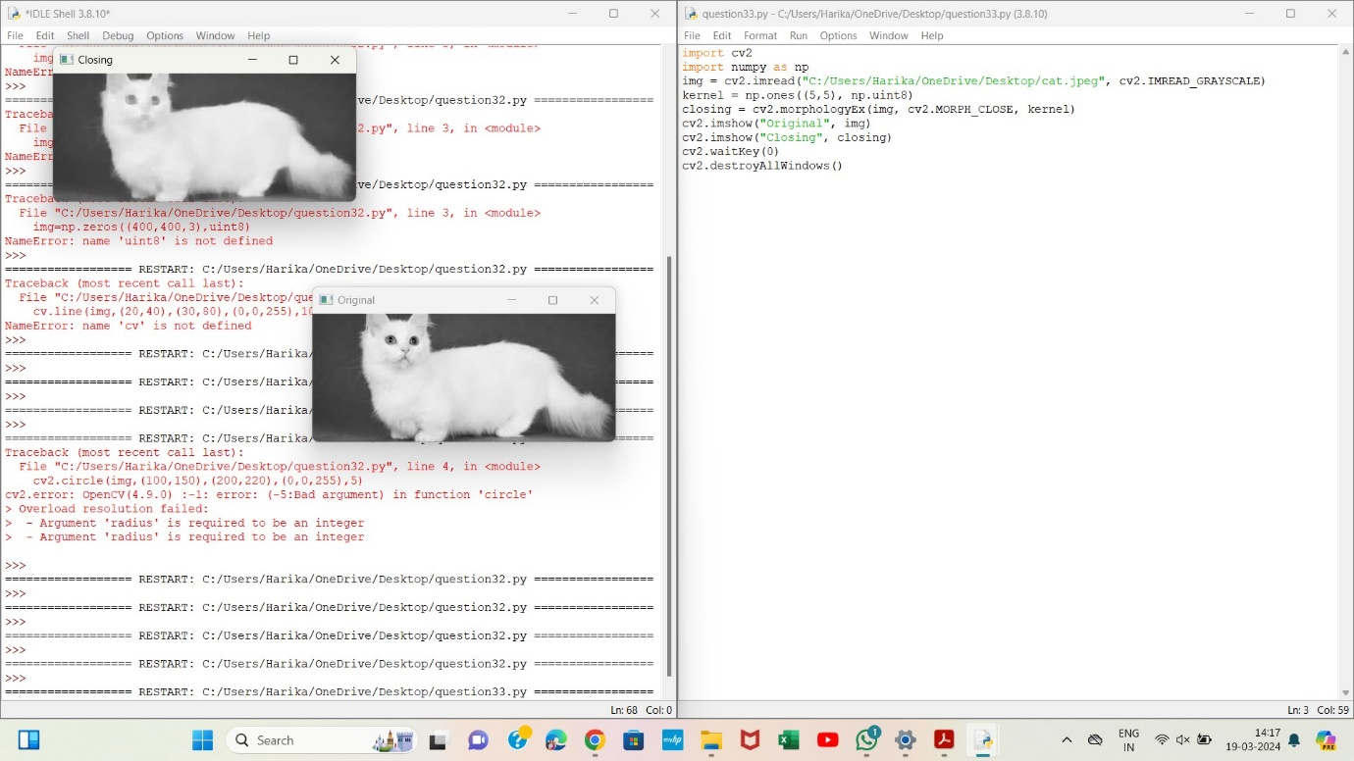

33. Morphological operations based on OpenCV using Morphological Gradient technique

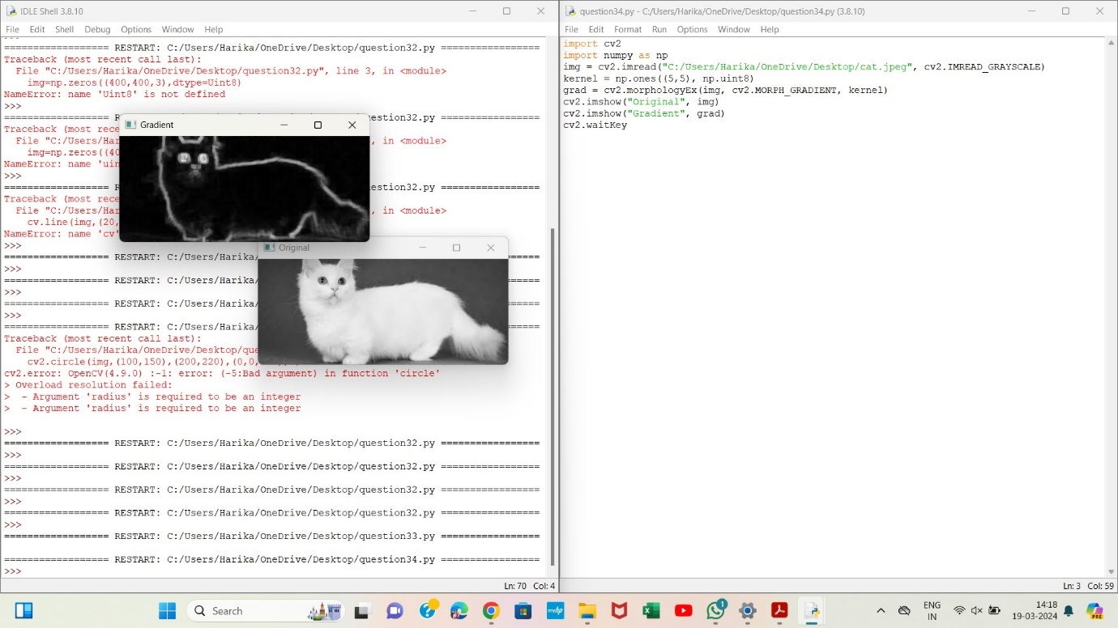

34. Morphological operations based on OpenCV using Top hat technique.

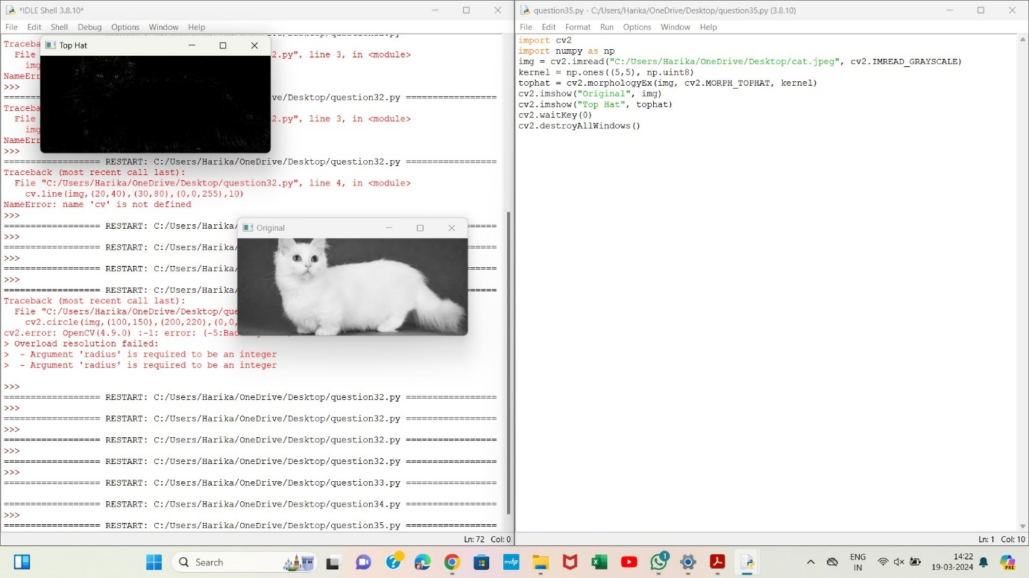

35. Morphological operations based on OpenCV using Black hat technique.

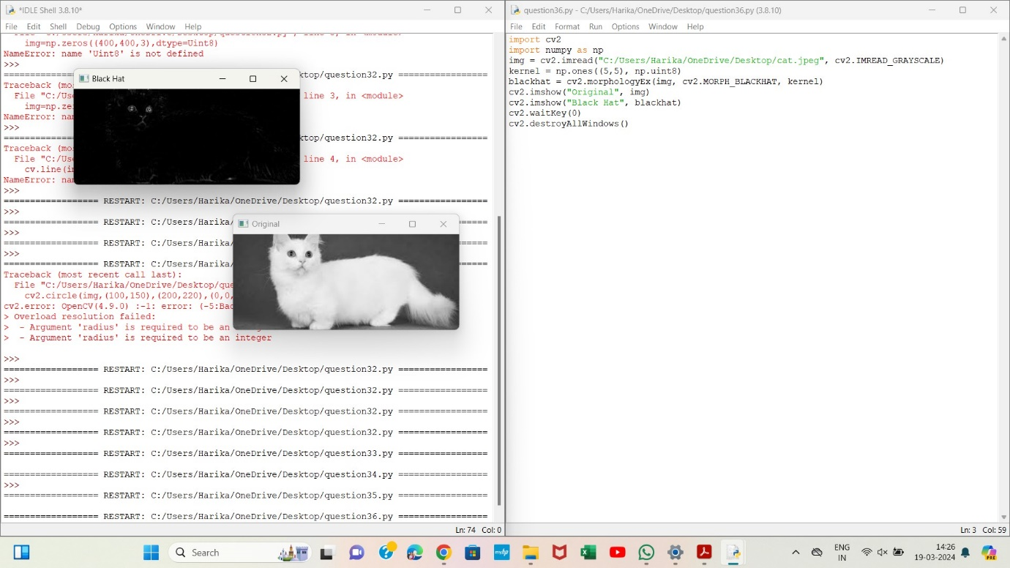

36. Recognise watch from the given image by general Object recognition using OpenCV.

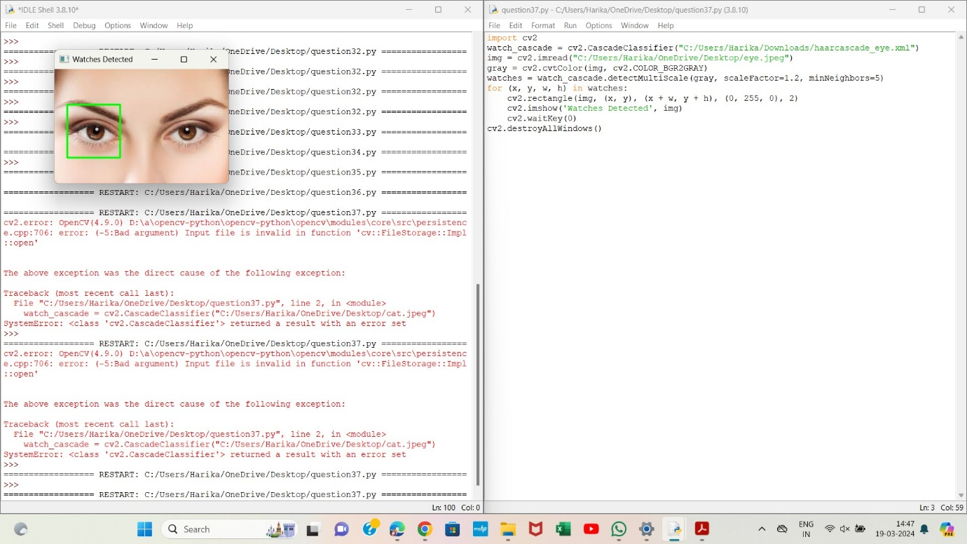

37. Using Opencv play Video in Reverse mode.

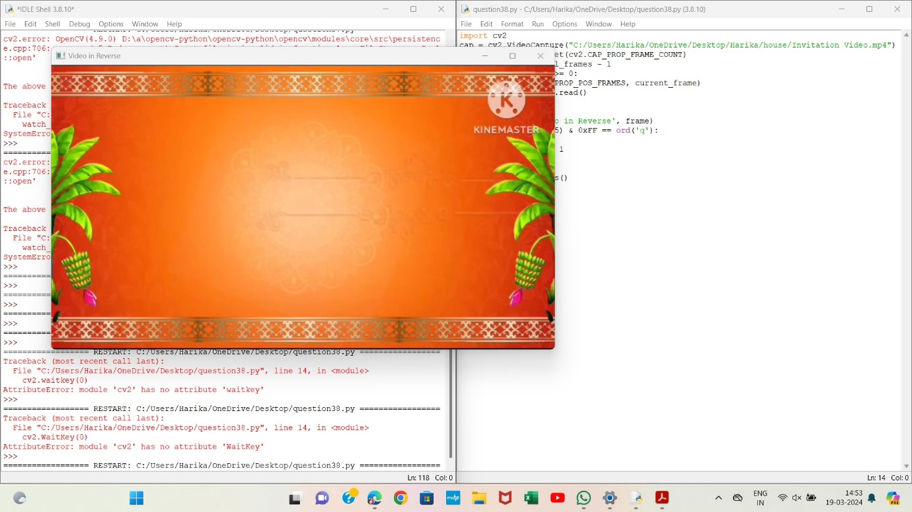

38. Face Detection using Opencv

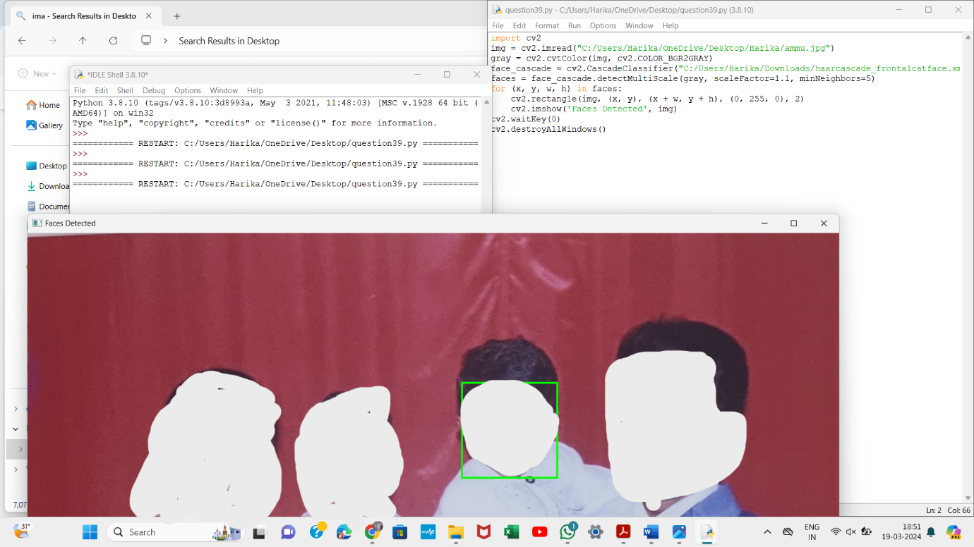

39. Vehicle Detection in a Video frame using OpenCV

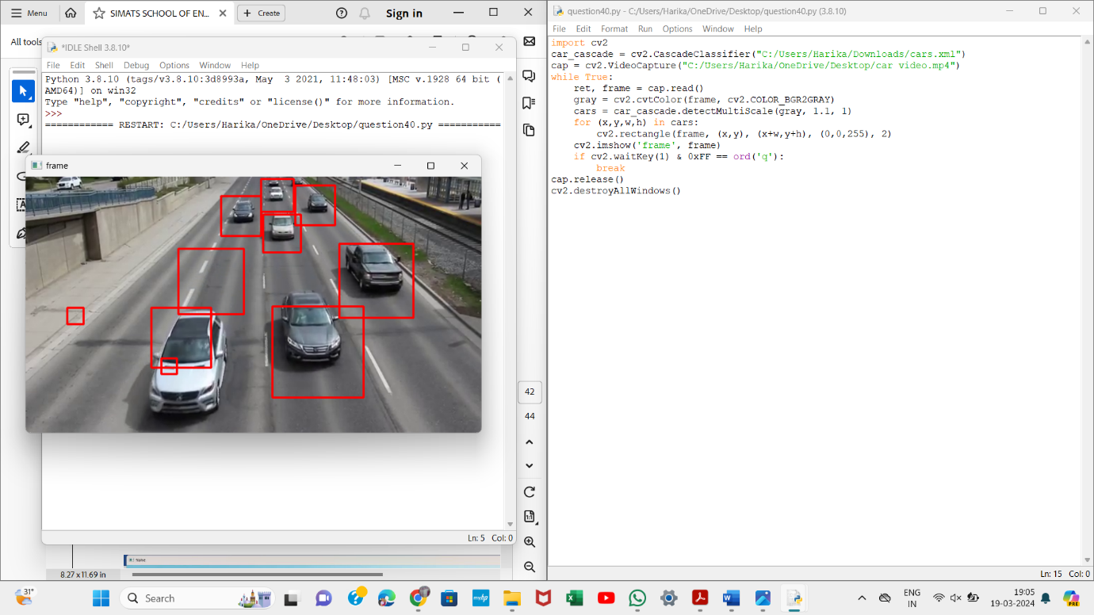

40. Draw Rectangular shape and extract objects

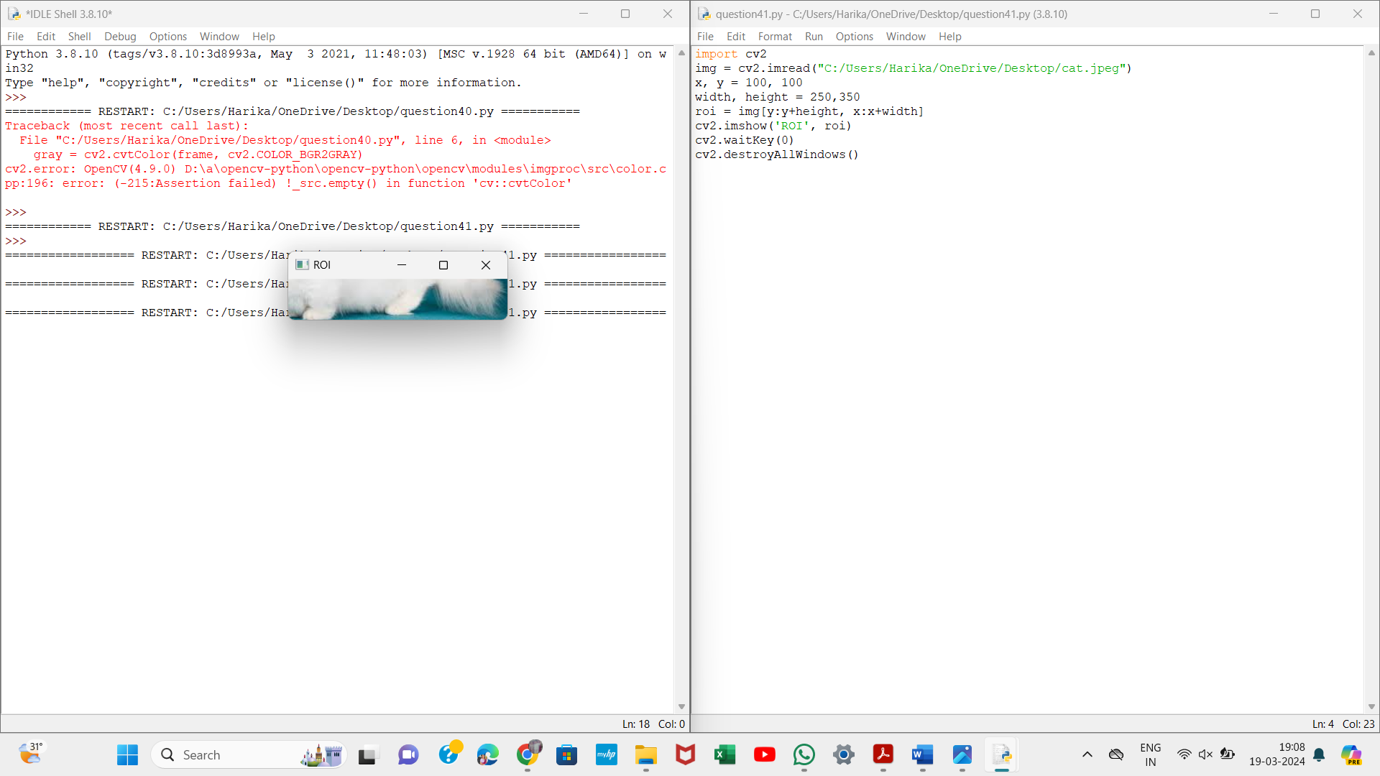

41.Draw Line, Circle and Rectangle using OpenCV

